Q. Task: Create a flowchart to display a "Good Morning" message based on a given time

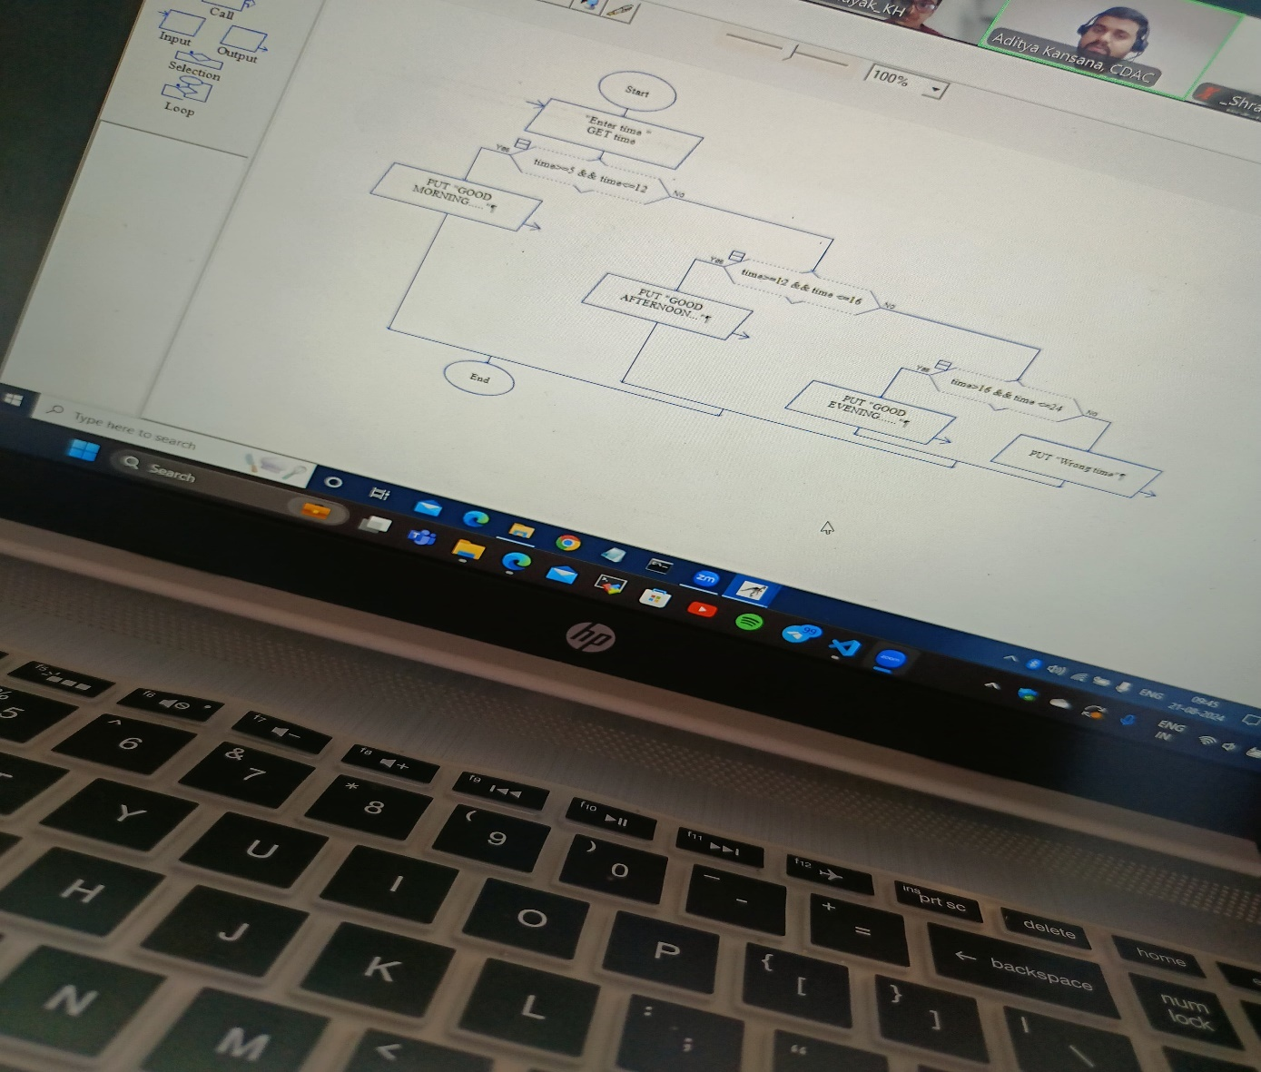

OR

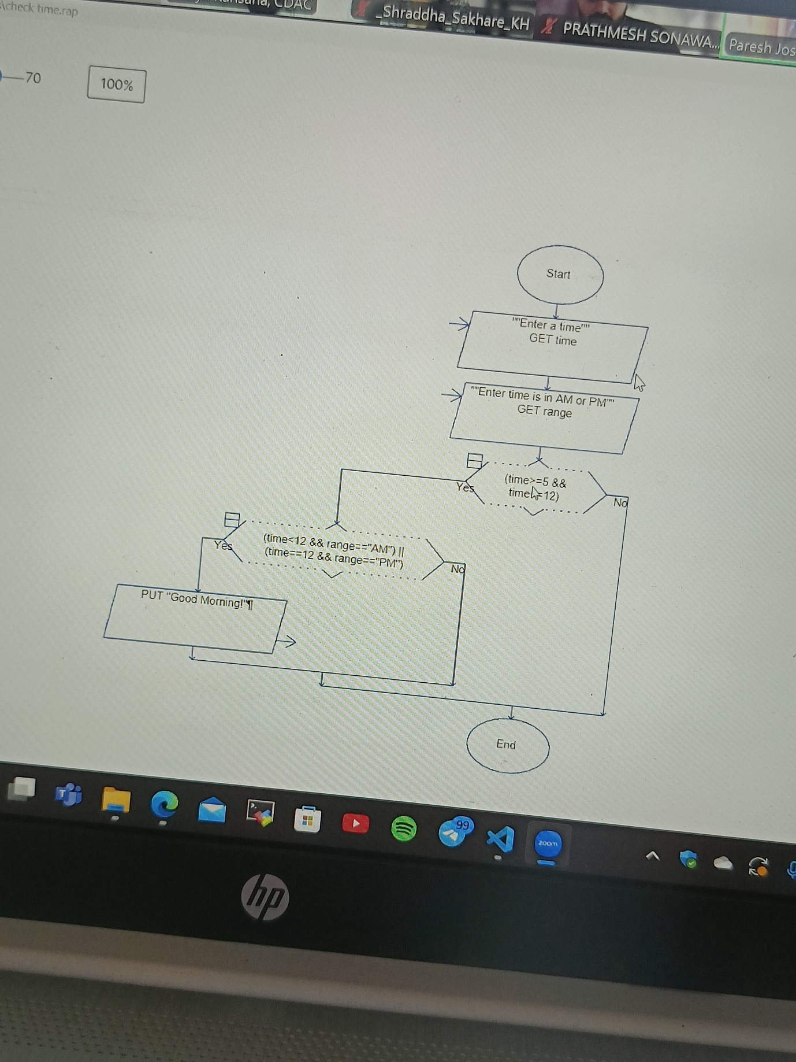

**TYPE CASTING**

Byte range = -128 to 127

So agar use bada no. use daloge to wo negative me output dega or uske liye bhi type cast karna padega

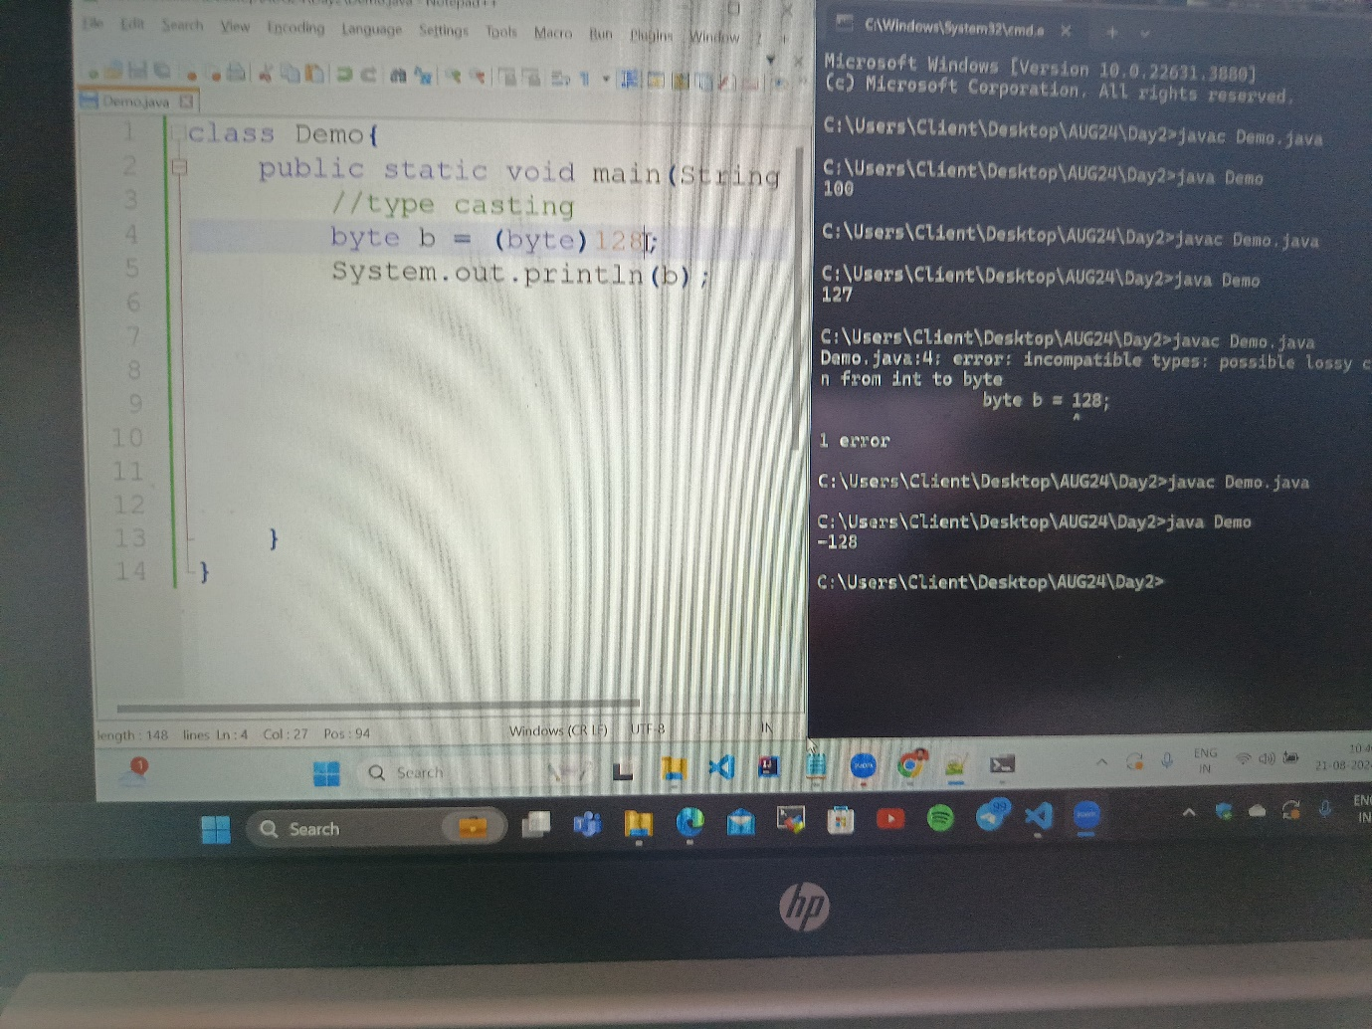

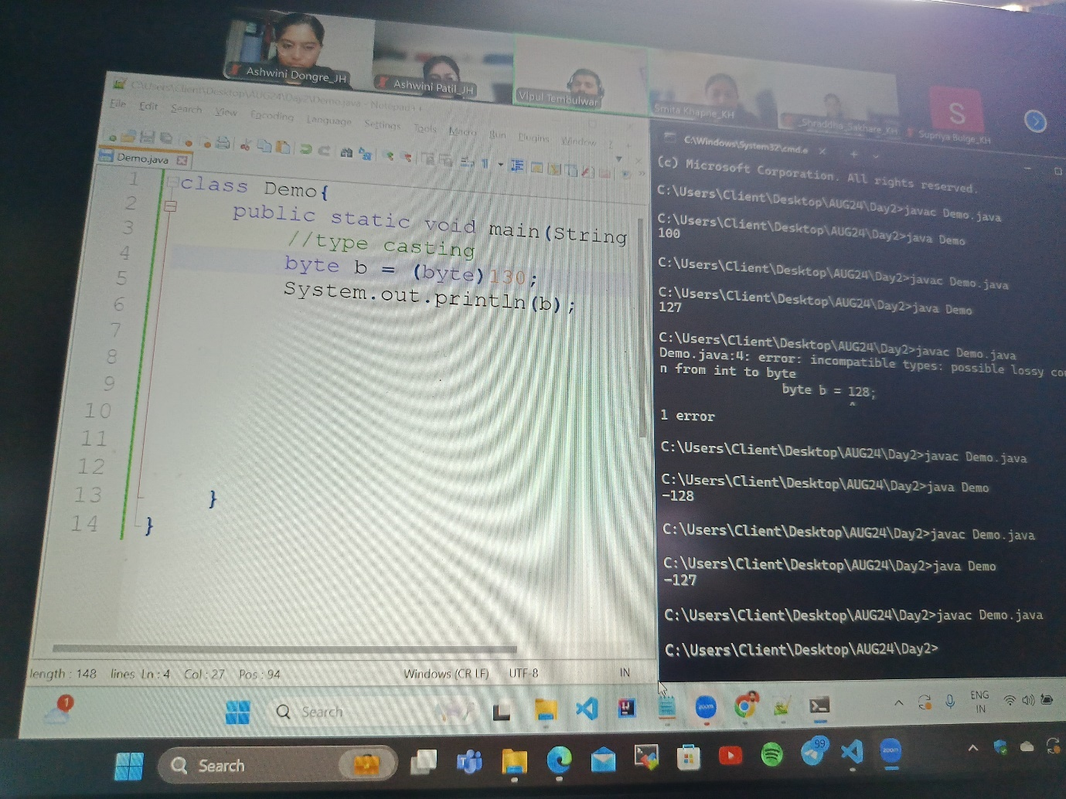

**ASCII VALUE**

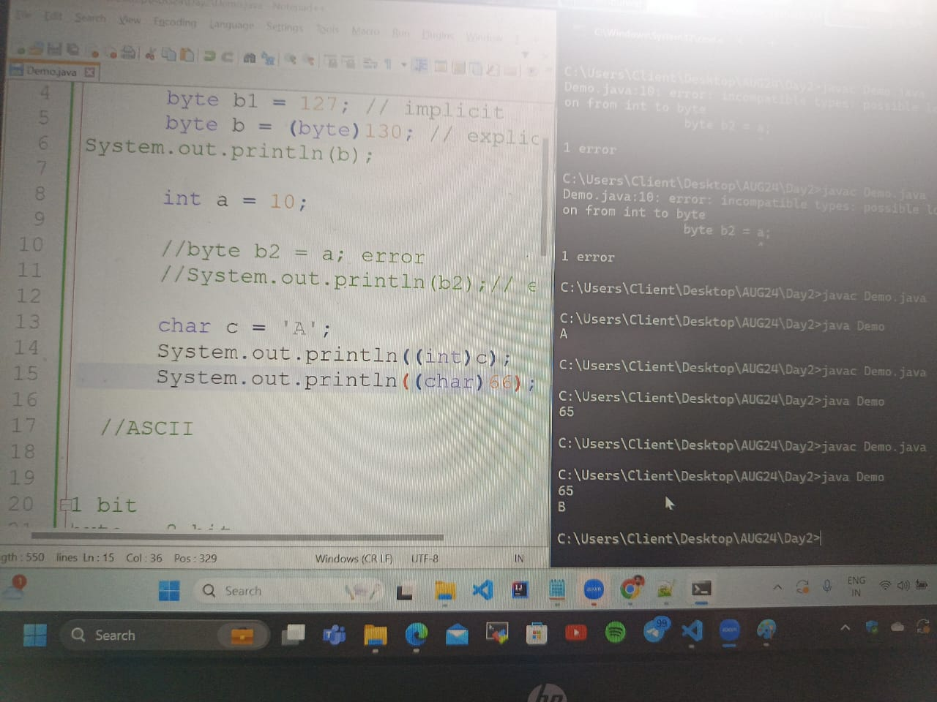

Agar char ki ascii value pata karni hai to aise kar sakte hai ya ascii char chahiye to bhi.

**FLOAT**

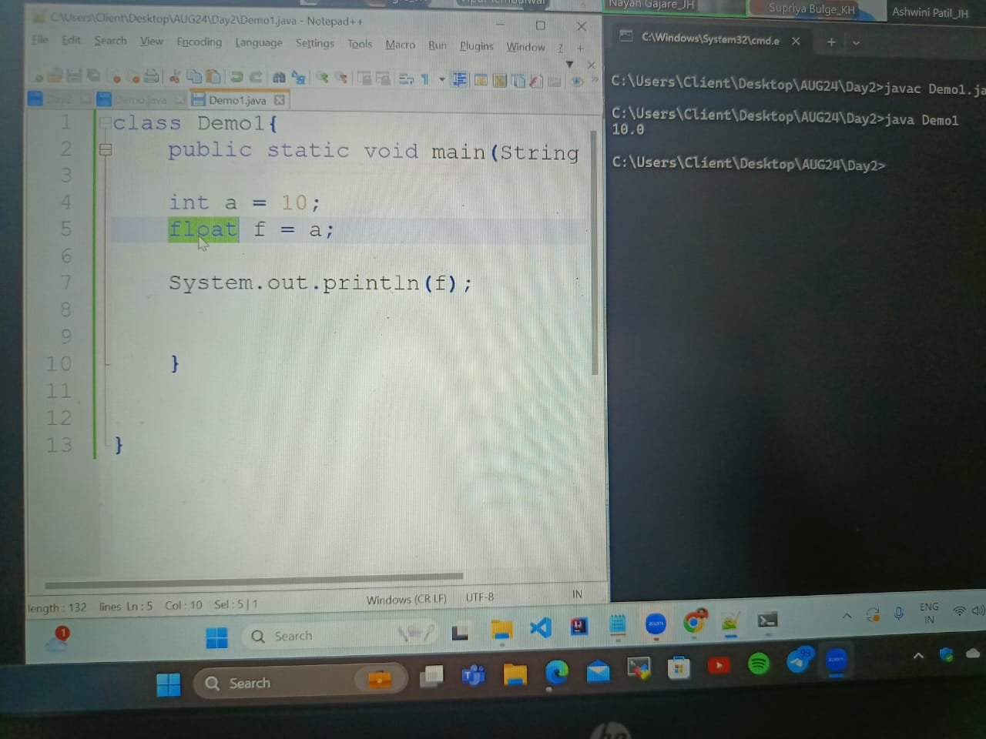

What happens ki float ka by default type double hota hai isliye aise kiya to 10.0 ans aya

Agar hamko decimal me ans nahi chahiye to aise karna pdega **float f = 1.0f** to ab ye float consider hoga.

**CONVERTING DECIMAL TO BINARY**

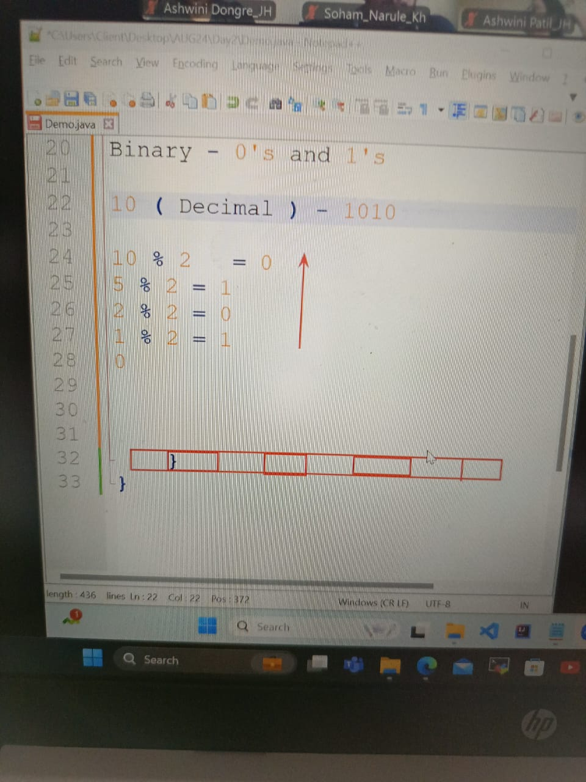

**INNER LOOP**

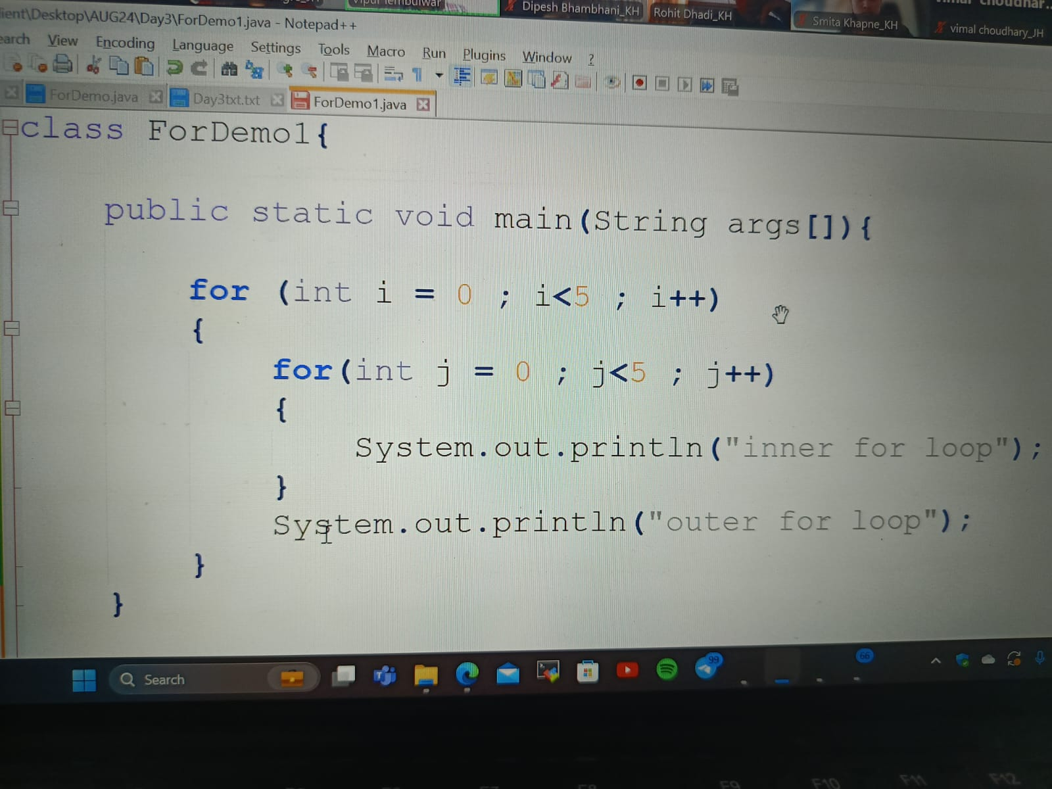

**Q.CODE**

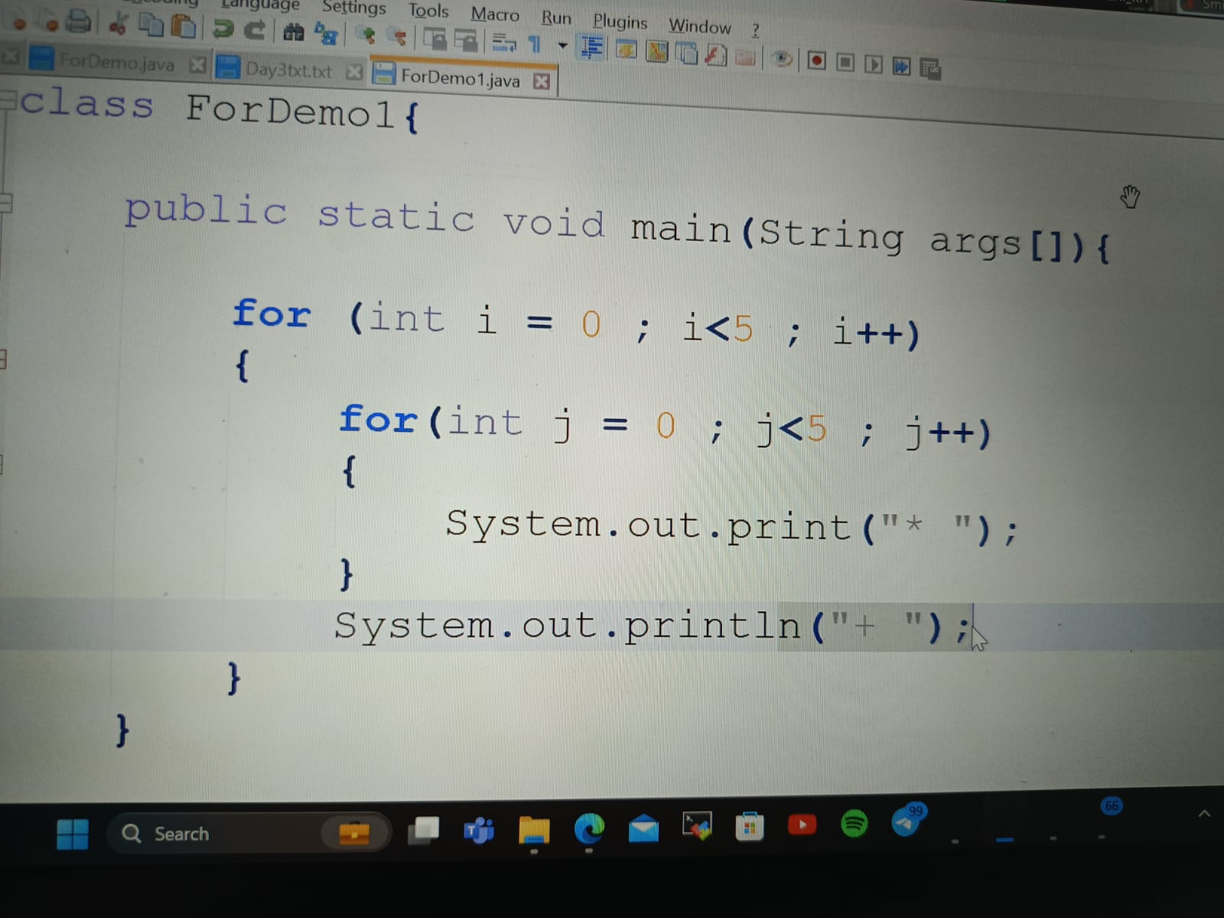

**OUTPUT**

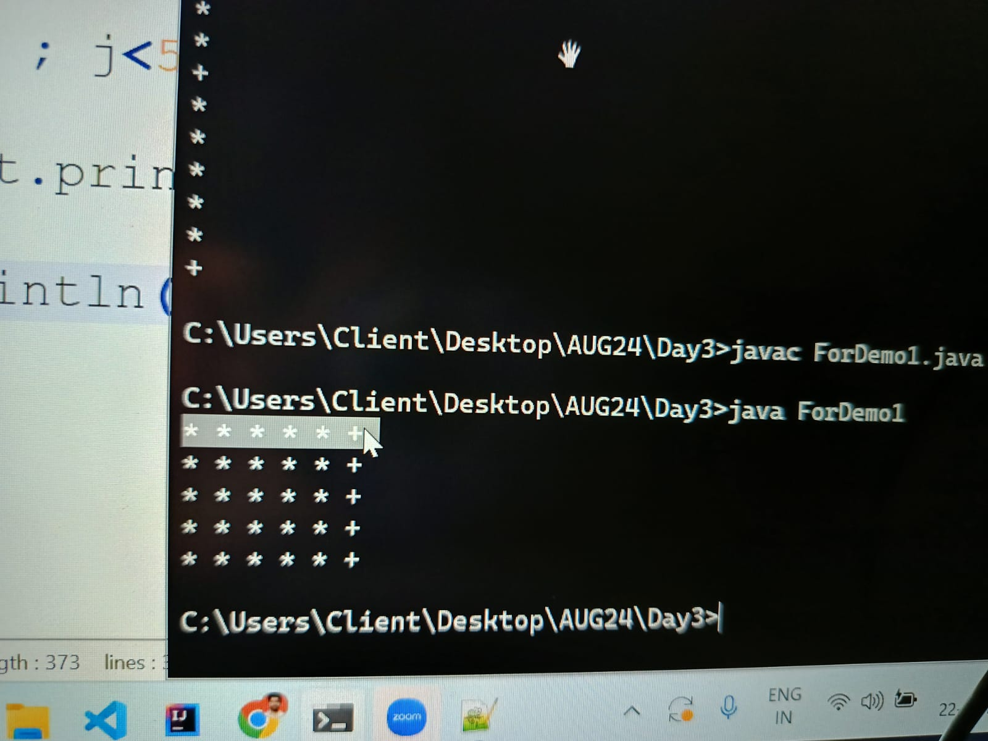

**Q.CODE**

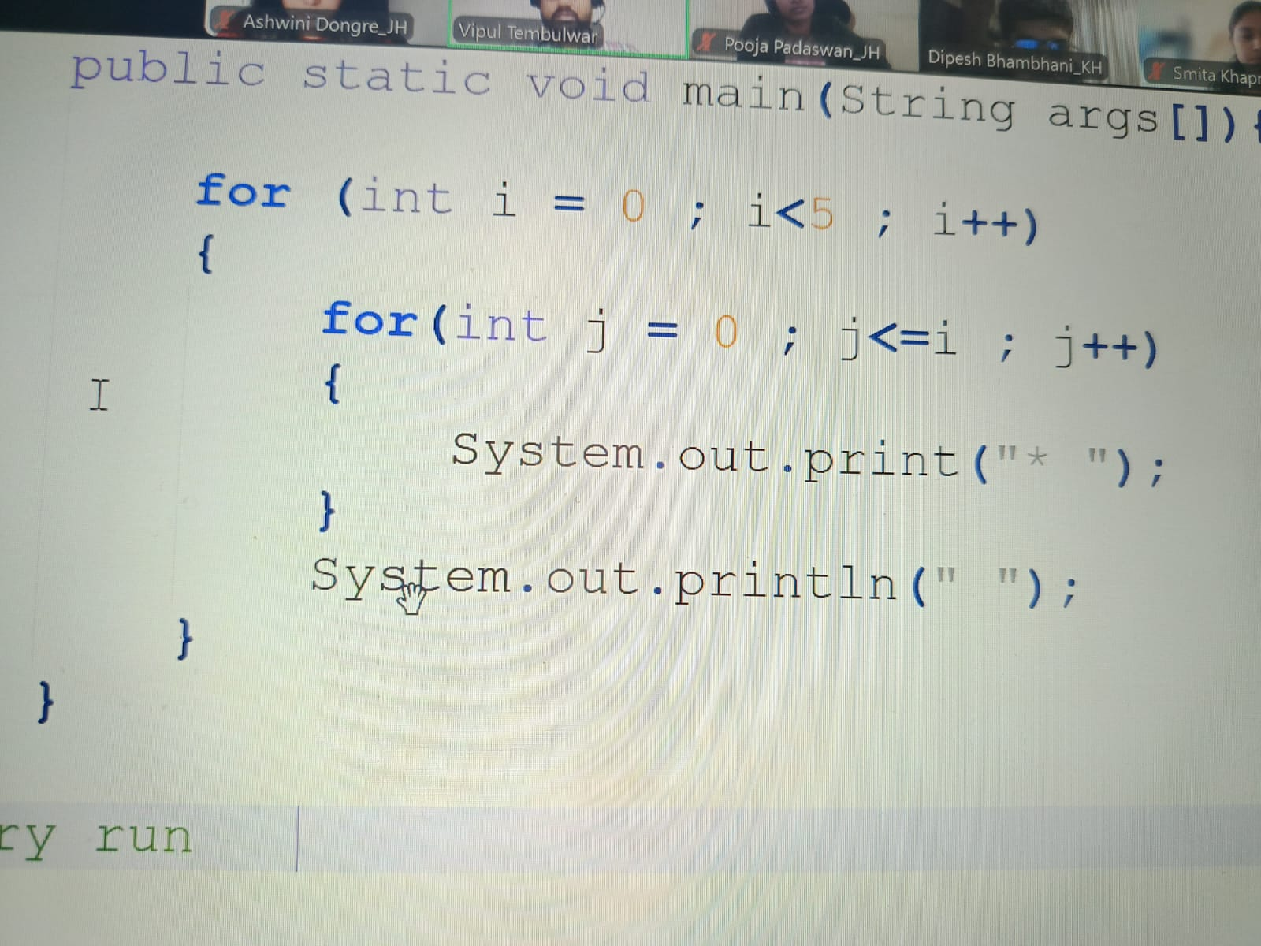

**OUTPUT**

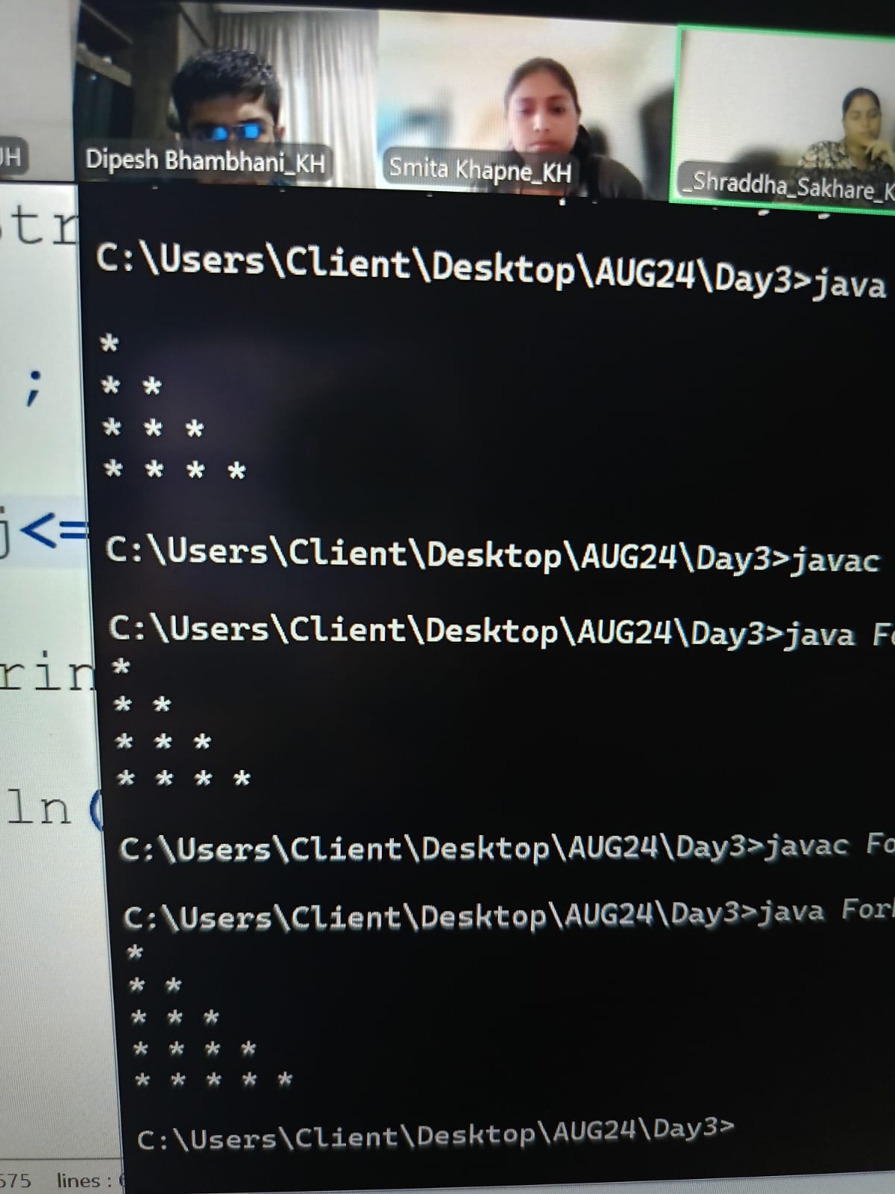

**CODE**

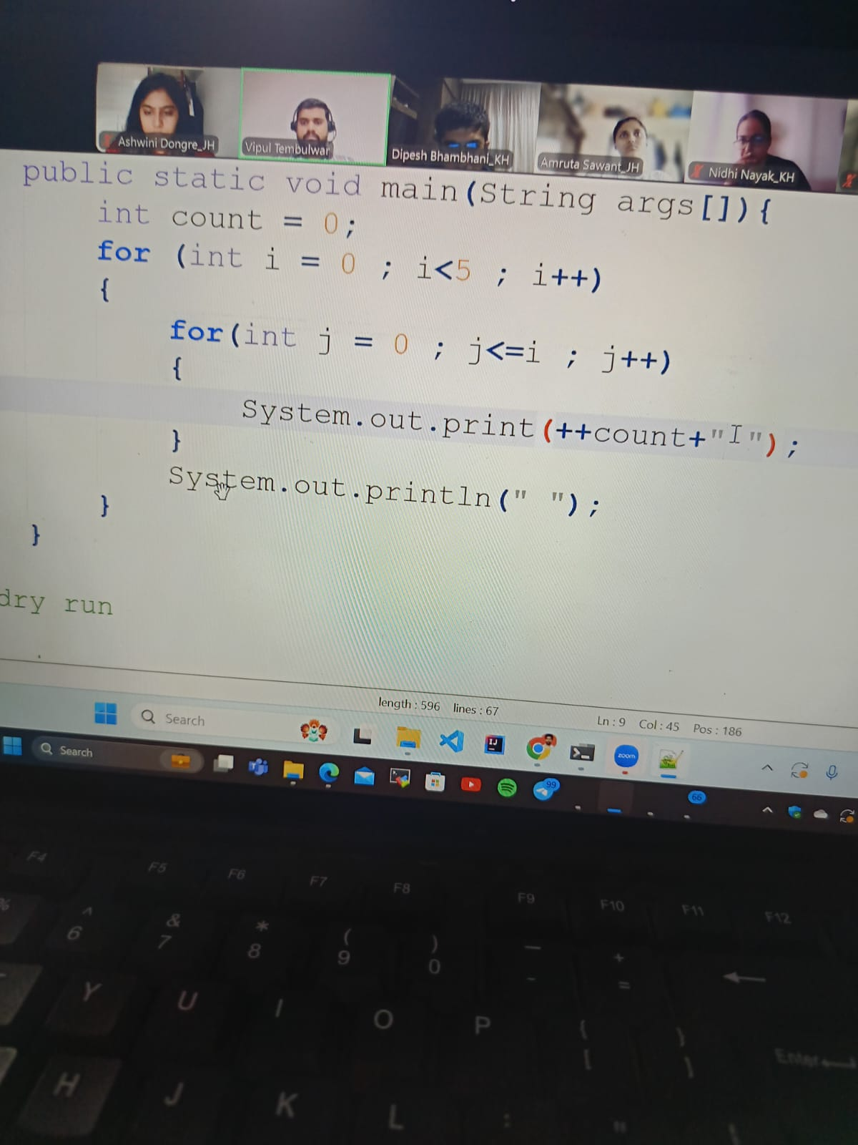

**OUTPUT**

**CODE**

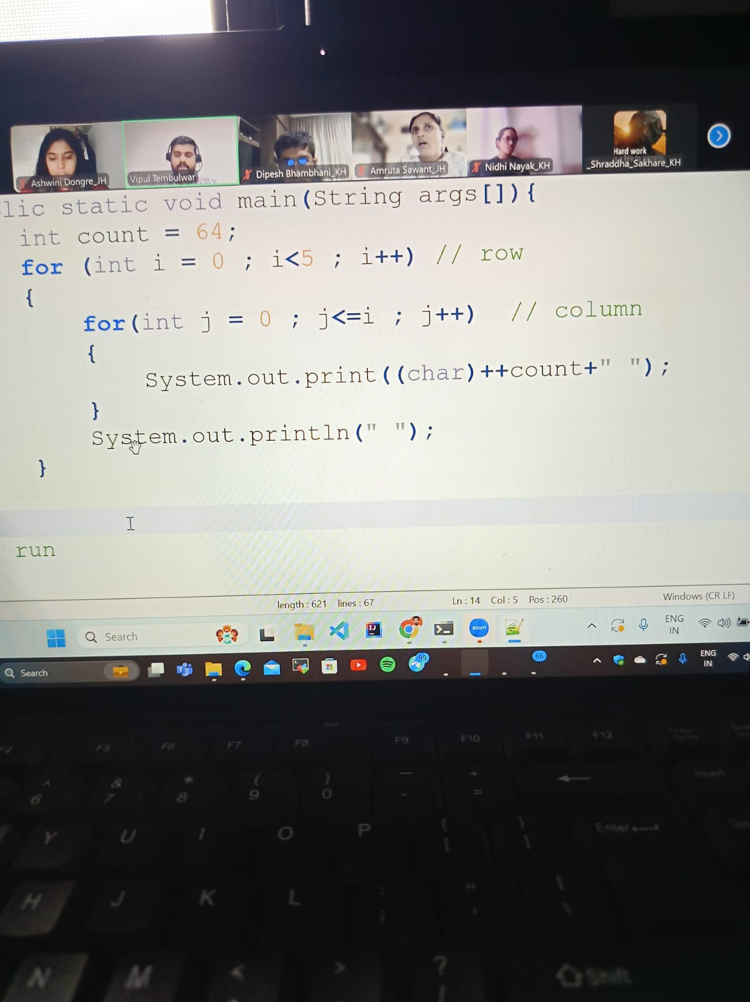

ROWS AND COLUMNS

**WHILE LOOP**

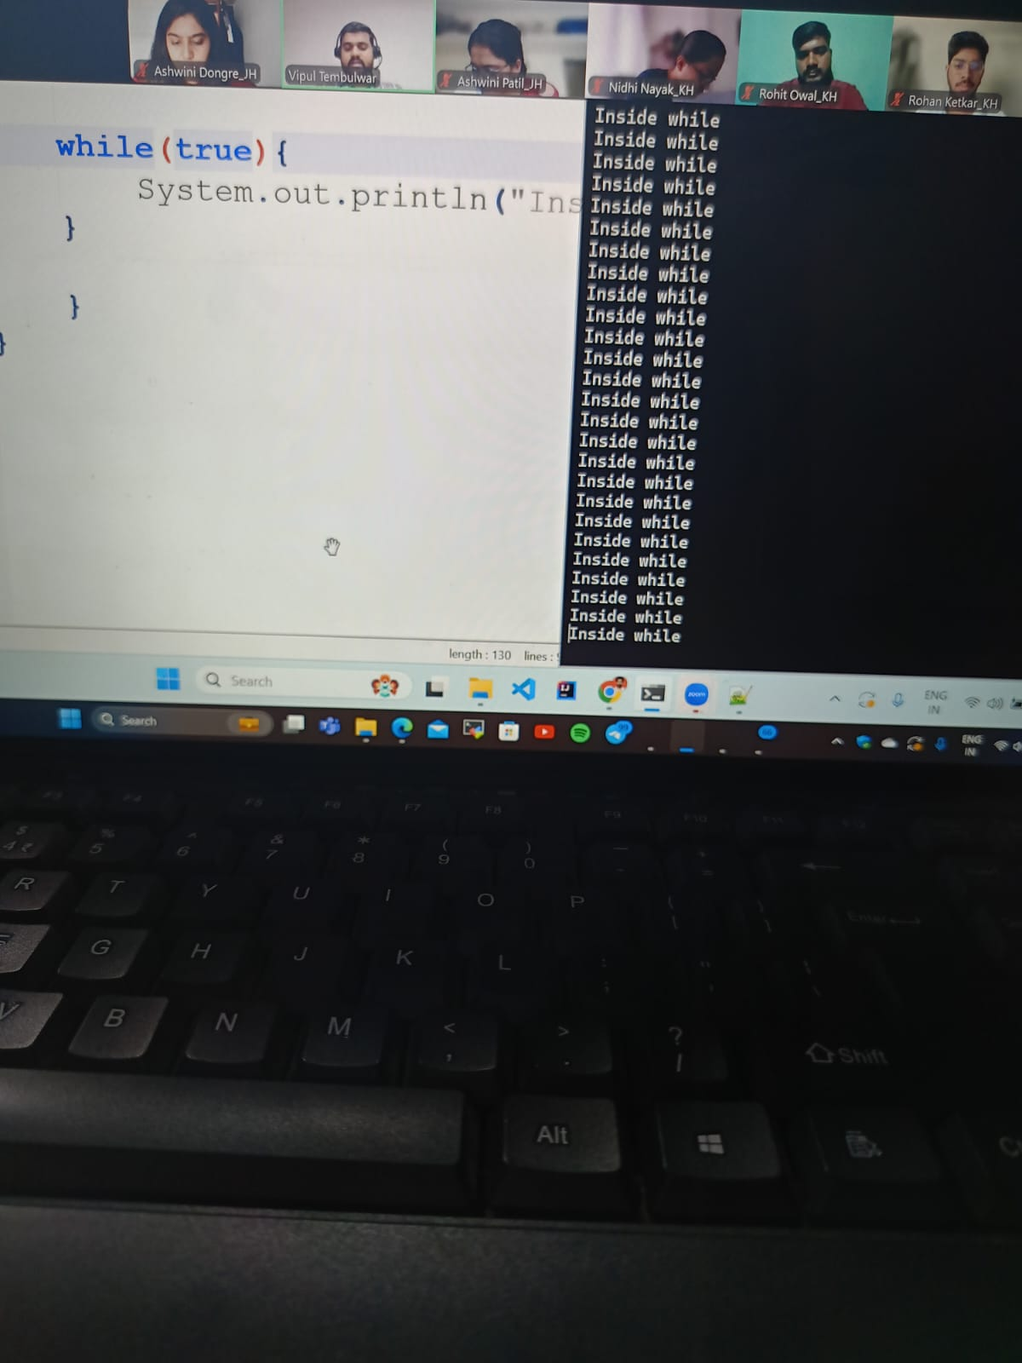

If the statement in while condition is true and there is no terminating condition

Then it will go in infinite loop

---------------------------------------------------------------------------------------------------------

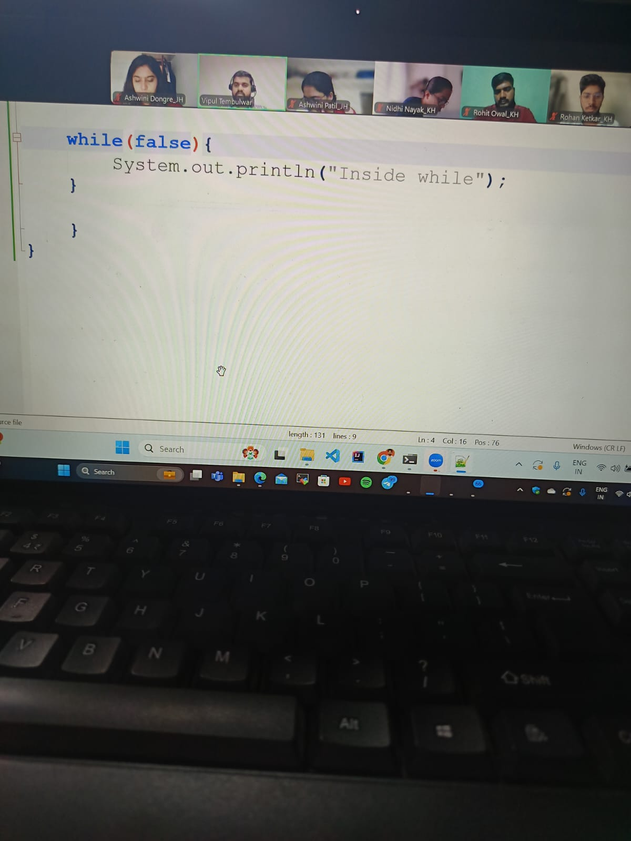

If the condition in while loop is false then it will give error unreachable

Statement compilation error

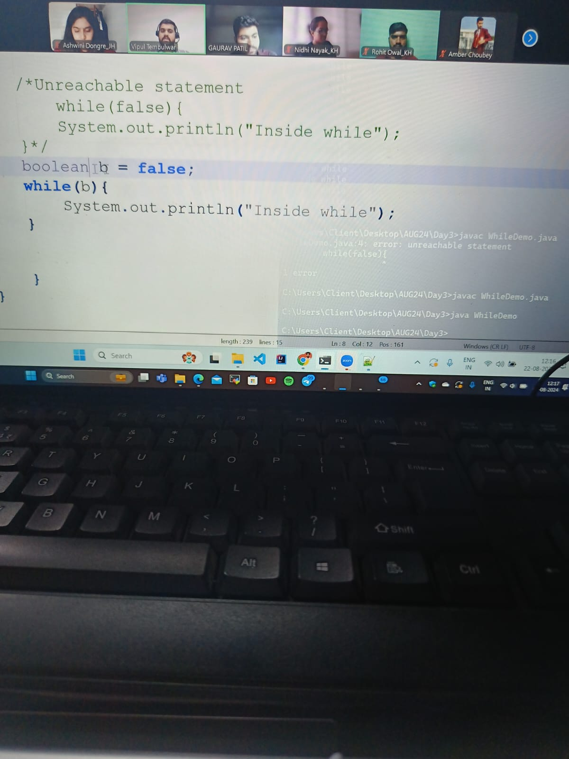

In this if we use Boolean it will runno compilation error

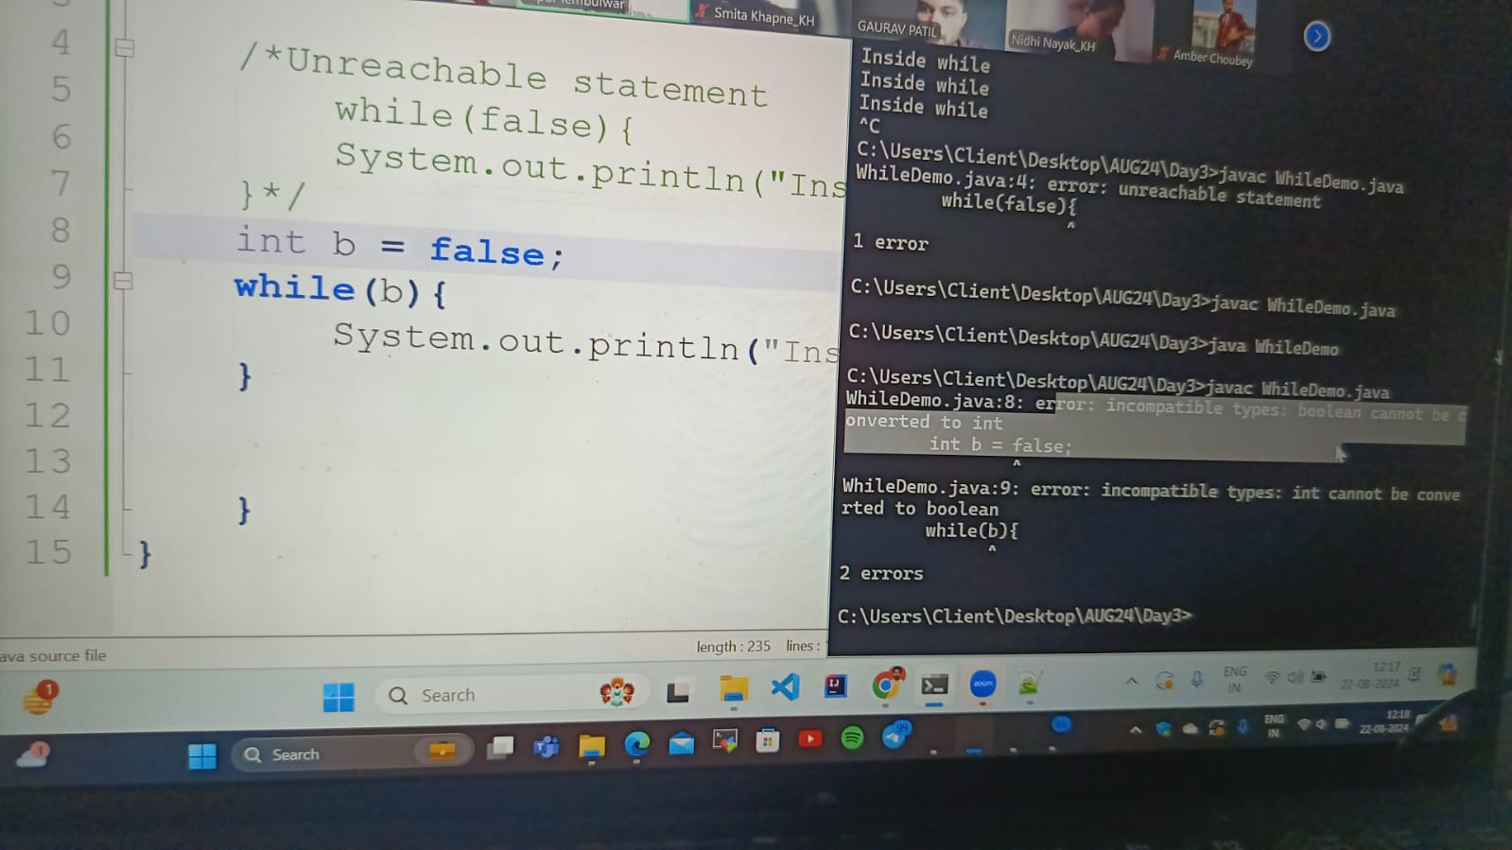

In this if we use int it will throw error ki Boolean cannot be converted to int

Type.

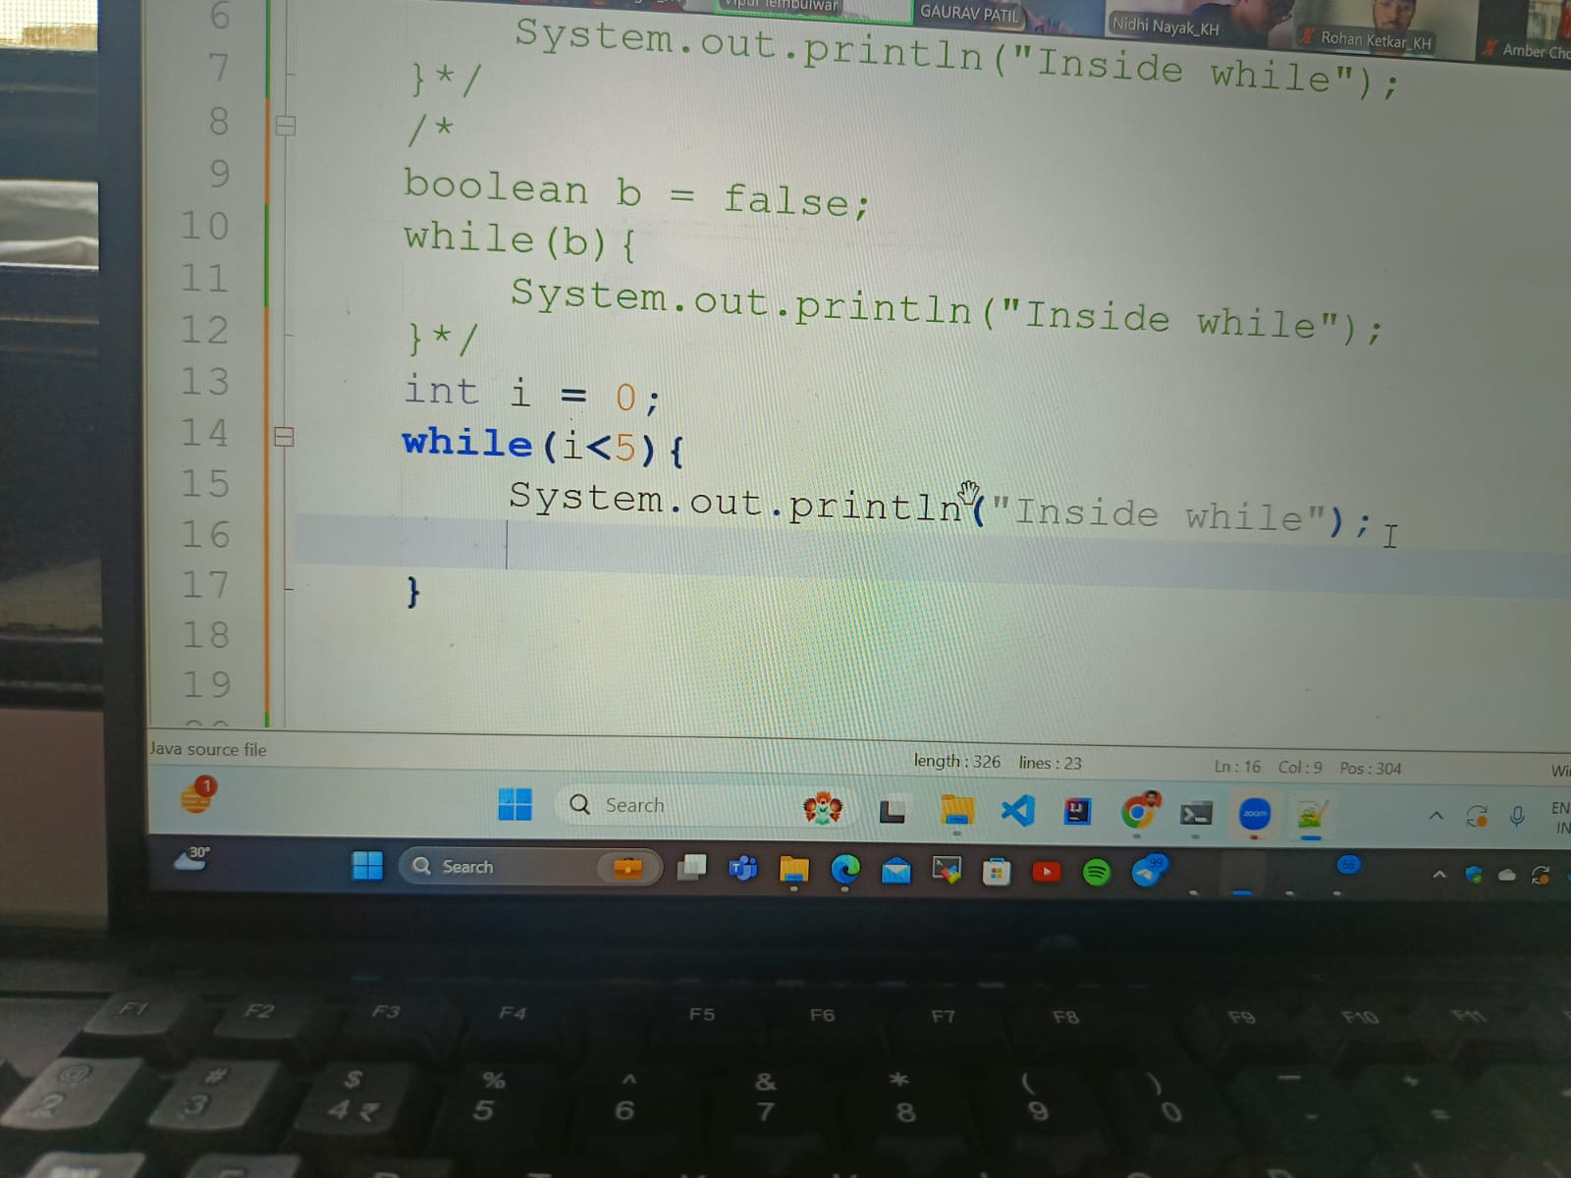

This is an infinite loop because there is no termination

-------------------------------------------------------------------------------------

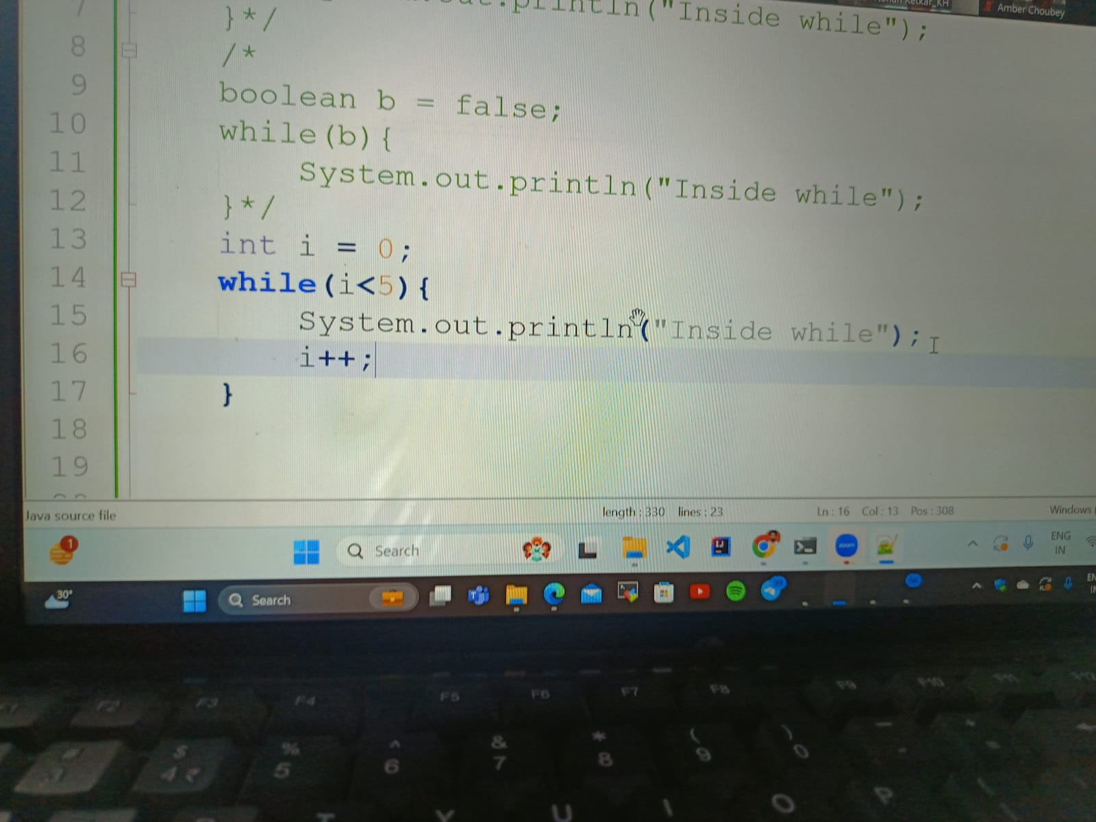

This is perfect for while loop

Inside while will print for 5 times

--------------------------------------------------------------------------------------------------

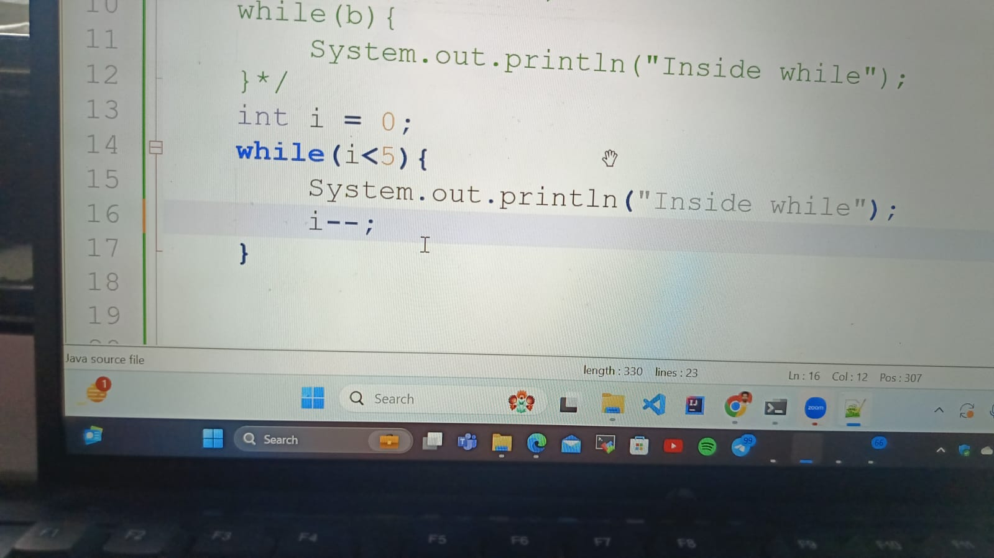

Again Infinite loop

--------------------------------------------------------------------------------------------------

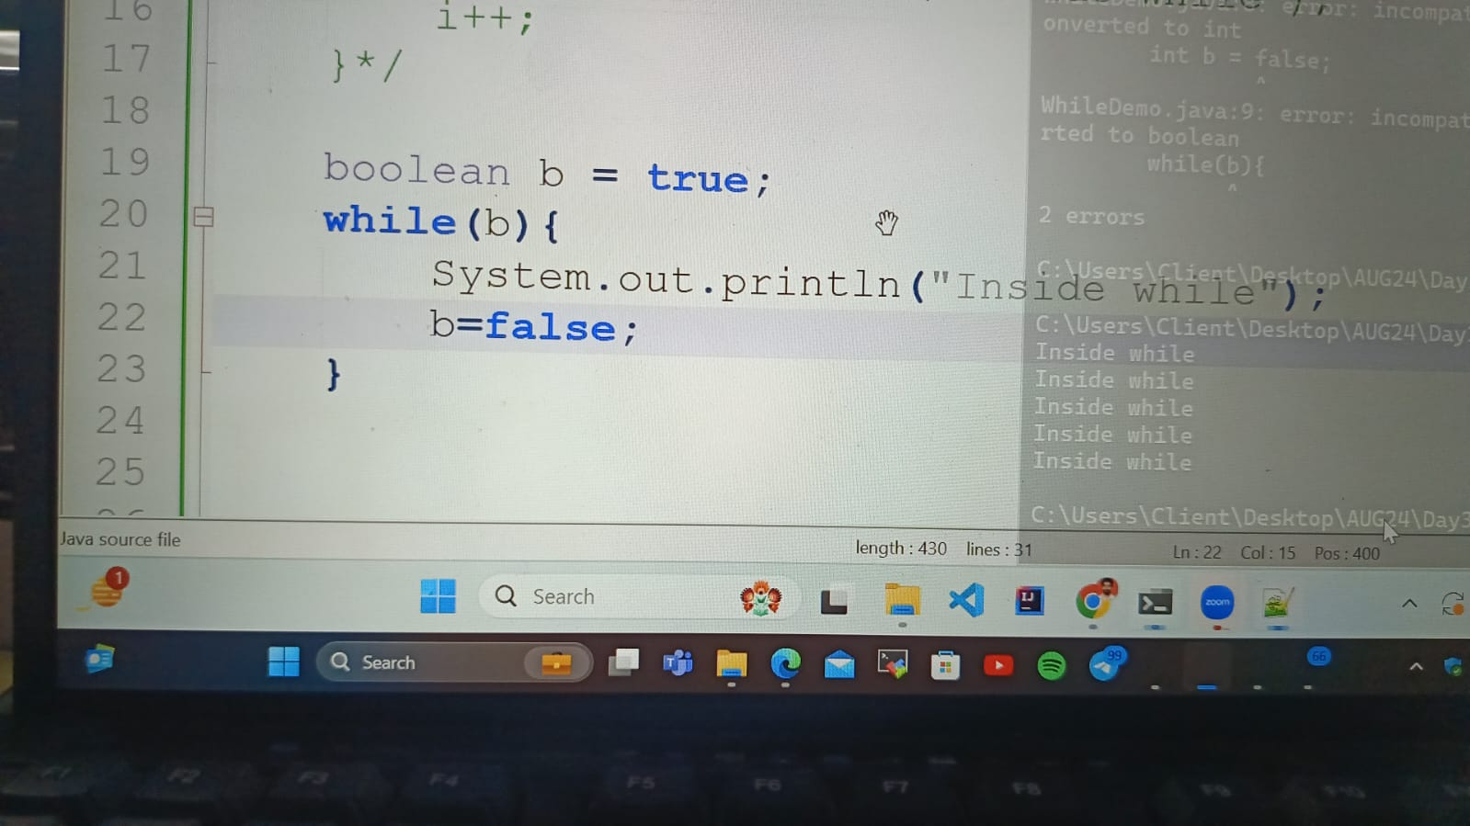

It will compile only once

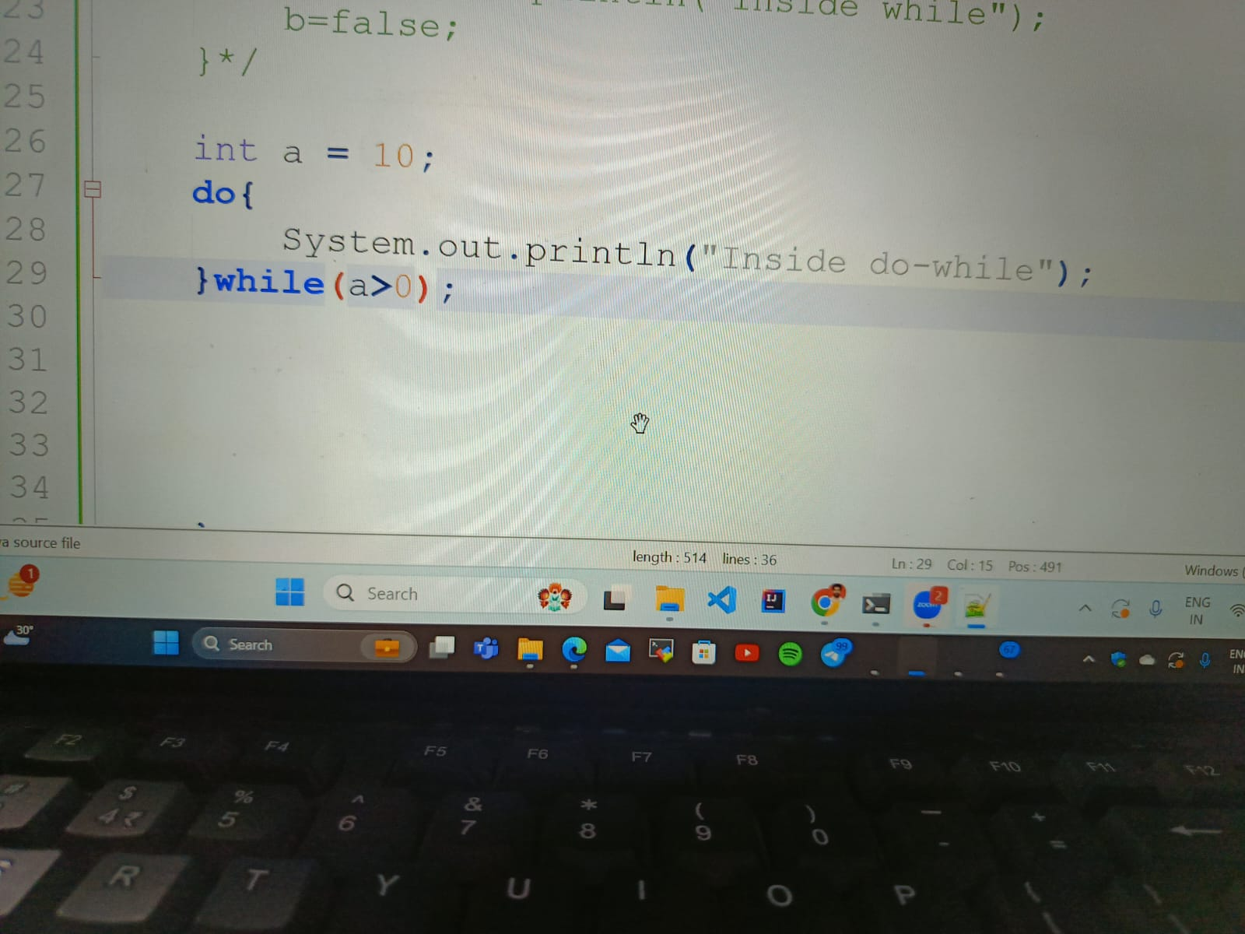

It is an infinite loop

-------------------------------------------------------------------------------------------------

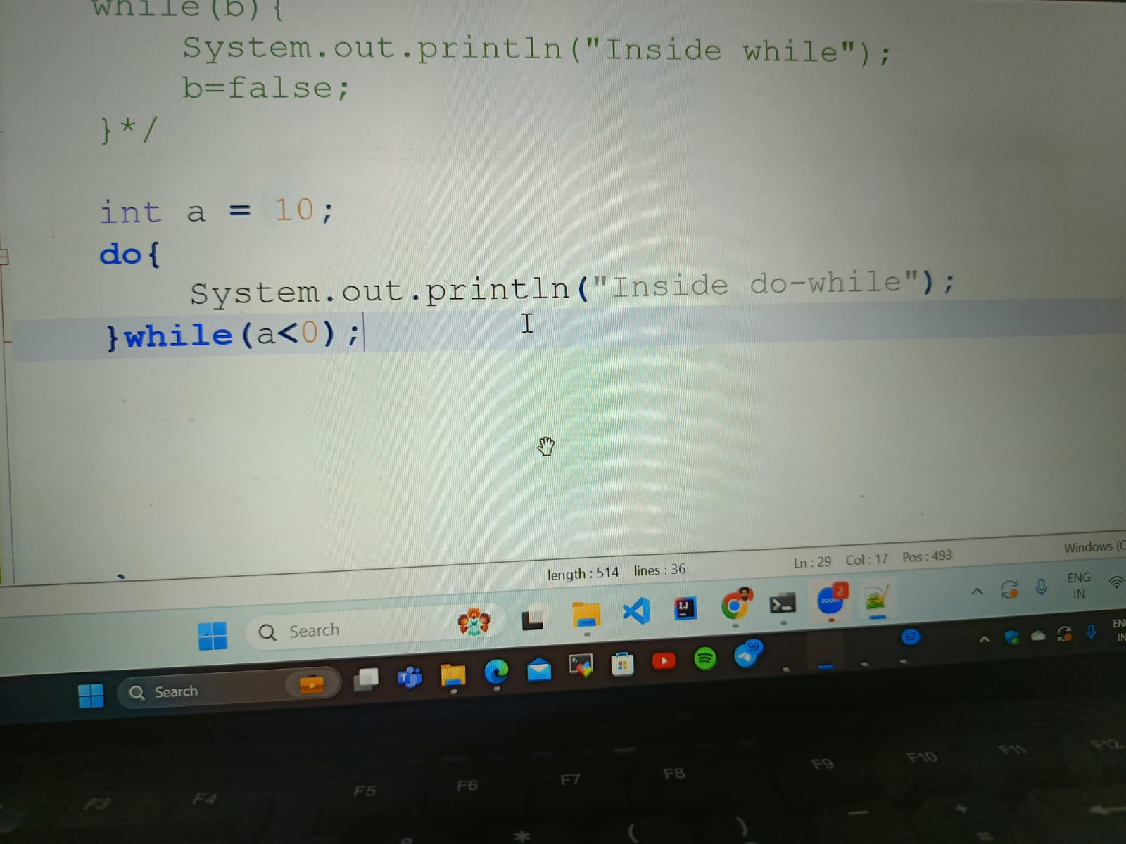

It will run once

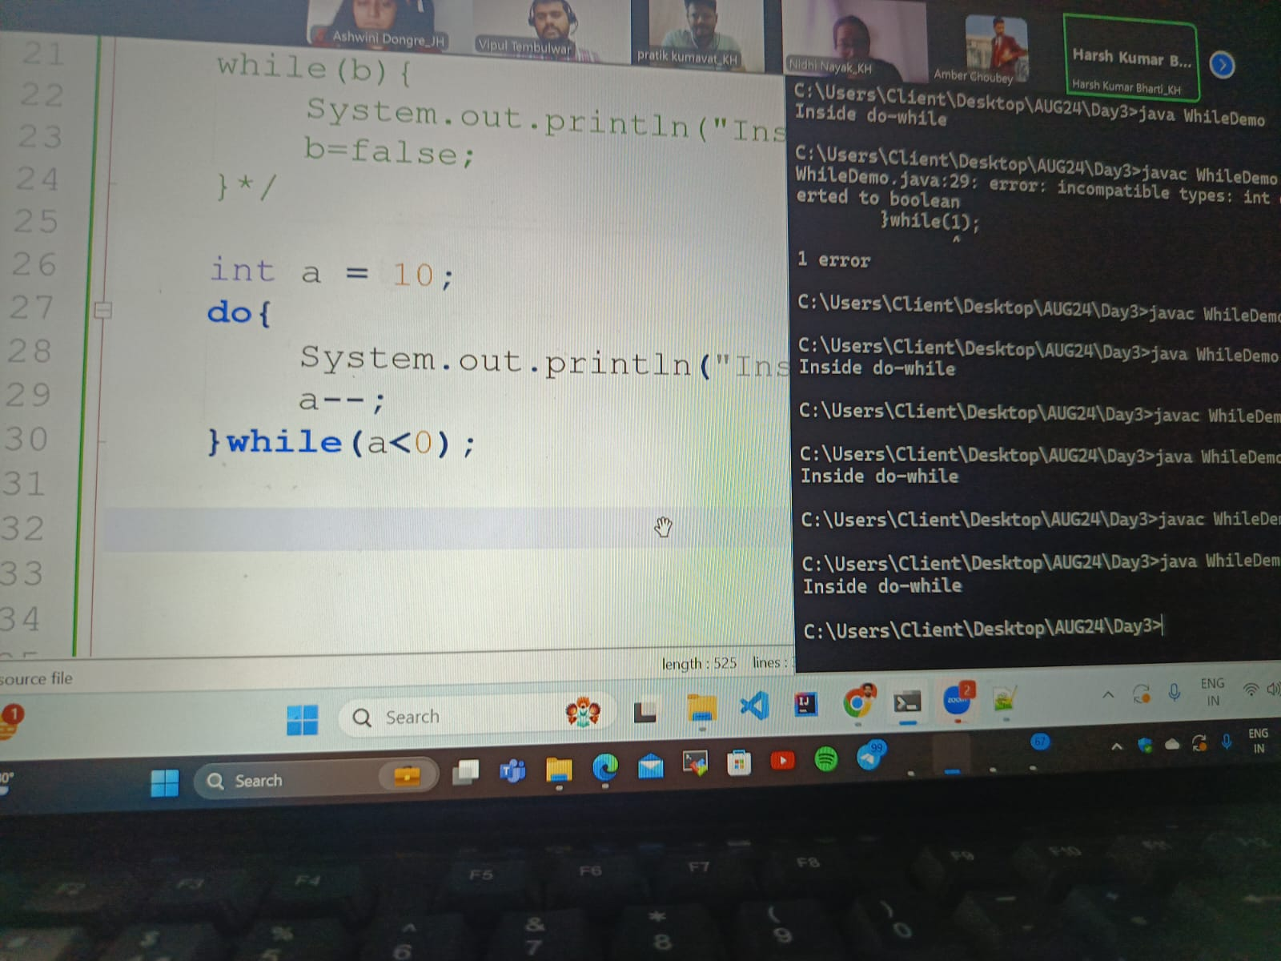

It will also run once

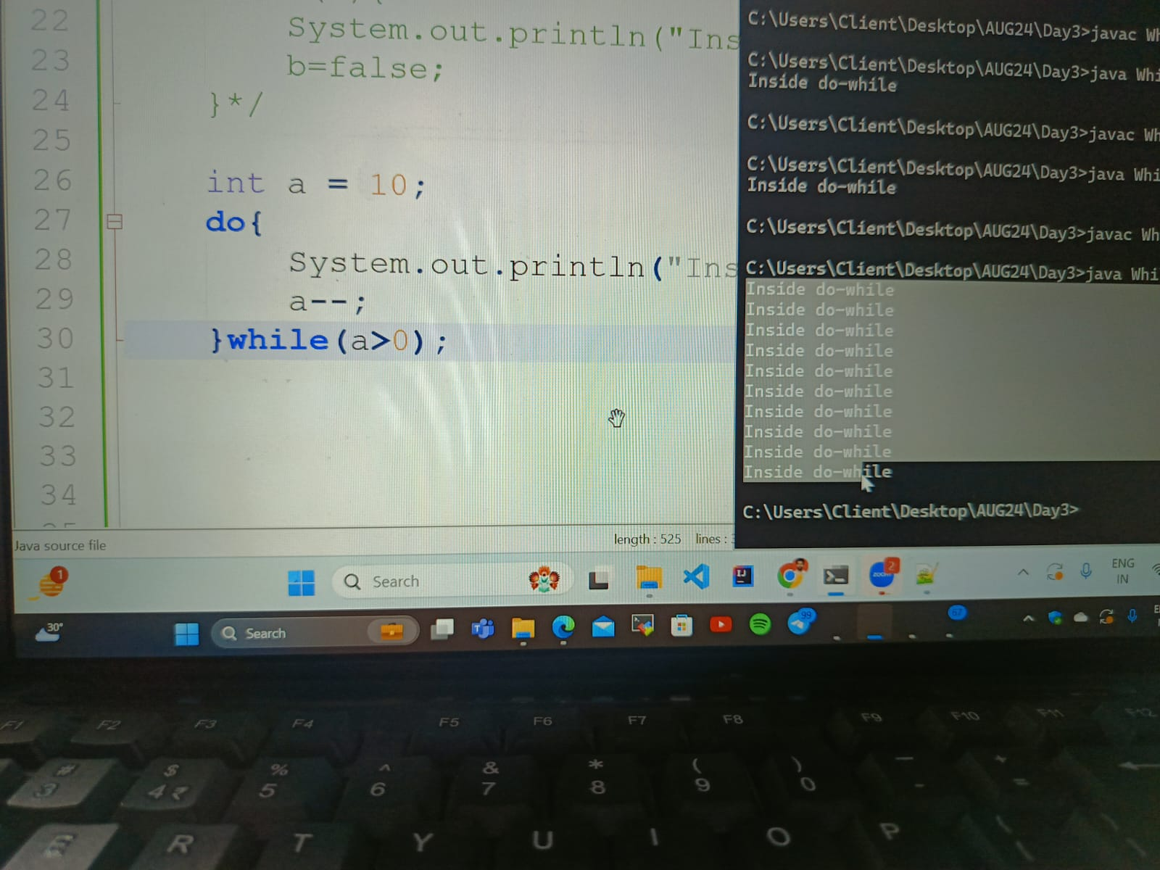

It will run 10 times